

Swing Labsheet

Implement the following swing applications

Q1) Write a swing application named SwingCounter as shown in the below Figure. Each time the "Count" button is clicked, the counter value shall increase by 1.

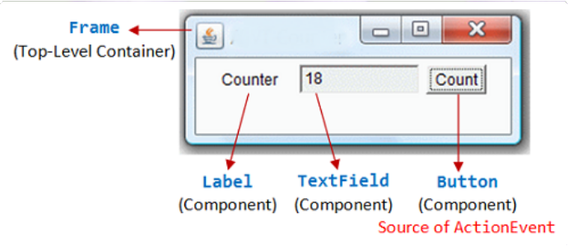

Q2) Modify the program (called SwingCounterDown) to count down, with an initial value of 88, as shown.

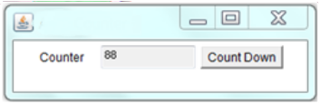

Q3) Modify the program (called SwingFactorial) to display n and factorial of n, as shown. Clicking the "Next" button shall increase n by 1. n shall begin at 1.

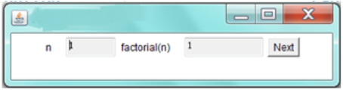

Q4) Modify SwingCount (called SwingCounterButtons) to include two additional buttons for counting down and reset the count value. Use (i) "this" class as listener for

all the 3 buttons; (ii) use one named inner class as listener for all the 3 buttons; (iii) use an anonymous inner class as listener for each button.

*Hints for (i) and (ii): You can use event.getActionCommend() to retrieve the label of the button that has fired the event.*

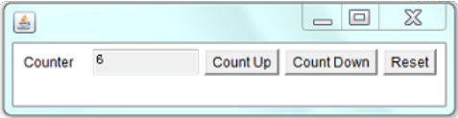

Q5)

Write a GUI program called TemperatureConverter to convert temperature values between Celsius and Fahrenheit. User can enter either the Celsius or the Fahrenheit value, in floating-point number.

Hints: To display a floating-point number in a specific format (e.g., 1 decimal place), use the static method String.format(), which has the same form as printf(). For example, String.format("%.1f", 1.234) returns String "1.2".

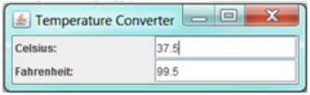

Q6)

Implement a simple calculator.

Hints:

Set the ContentPane to BorderLayout. Add a JTextField (tfDisplay) to the NORHT. Add a JPanel (panelButtons) to the CENTER. Set the JPanel to GridLayout of 4x4, and add the 16 buttons.

All the number buttons can share the same listener as they can be processed with the same codes. Use event.getActionCommand() to get the label of the button that fires the event.

The operator buttons "+", "-", "*", "/", "%" and "=" can share a common listener.

Use an anonymous inner class for "C" button.

You need to keep track of the previous operator. For example in "1 + 2 =", the current operator is "=", while the previous operator is "+". Perform the

operation specified by the previous operator.

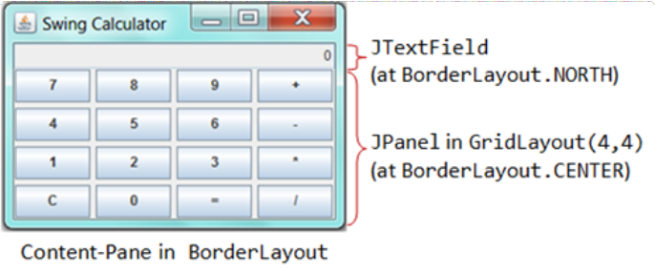

JDBC and Swings

Q7)

Using JDBC connectivity which was used in the previous [labsheet](https://amritauniv.sharepoint.com/sites/ObjectOrientedProgrammingJune-Dec2020/SitePages/JDBC-Labsheet.aspx) where books table was used. Modify the same program with JMenu having the a Menu named Table

Operation and Menu Items --> Display, Update, Search, Delete, Insert and Close [*which does the same functionality mentioned in the JDBC labsheet*].

The following should be used to visually show the result for each functionality:-

1. Display - The result can be either populated in JTable or not-editable text- field
2. Update - The id and price can be taken as input using text fields. Using the returned value of the updation, given a popup message if successfully updated or failed according to the count returned.
3. Search - The minimum and maximum price can be taken as input using textfields and populate in JTable.
4. Delete- Input the id using input dialog box and excecute the delete query.
5. Insert - Using appropriate components take the field input to exceute the query.
6. Clase- Exit the application